Natural Language Processing
Project Report

ON
Contextify: An Advanced Context-Aware Neural Machine
Translation System for English-Hindi Translation with
Integrated LLM Analysis

LUCY UGUWANEKE
PARTH BHUTADA
SWAPNIL SAMRAT

ABSTRACT
In a time when the world has never been more connected, linguistic differences continue to create significant barriers to communication across cultures. Existing translation services, such as Google Translate, are able to provide literal translations that are typically very accurate. However, existing translation services cannot convey the cultural nuances, idiomatic phrasing, or contextual meaning that gives language depth. This limitation is frustrating for those communicating across cultures and generates misunderstanding across professional, educational, and social contexts where cultural subtext can sometimes be as important as the literal sentence. It is this gap that Contexify seeks to fill with its unique translation technology. Contexify is a departure from the current limitations of machine translation. Contexify is not merely a translation service but operates as a cultural interpreter rather than a translator, as it employs artificial intelligence to detect idioms, slang, and cultural references in real time to help understand the specific cultural context meaning with the accurate translations and provides users with their intended meaning. This dual-layer approach ensures users know not only what is said, but what was intended to be communicated, in any context whether it is business negotiations, educational settings, or even casual conversations. The technical workings of Contexify are based on various state-of-the-art machine translation models, including MarianMT, M2M100, and NLLB-200, with NLLB-200 being the most versatile performer based on complete evaluations. These models were trained and tuned with a carefully constructed dataset of sentence pairs in English and Hindi striated with idiomatic and culturally relevant information. Another key aspect of the system is the inclusion of Llama 3.2 through Ollama to provide cultural context, through the identification of non-literal phrases, and provide notes in the target language. Contexify is applicable across multiple fields and can have an impact on society. In a global business setting, it could save businesses from costly misunderstandings by clarifying the meaning of idiomatic and culturally relevant references in business communications. In education, it provides students an opportunity to learn how to use the living language, beyond a textbook definition. As it relates to diplomacy and governance, it enhances clarity in cross-cultural. Lastly, within the context of entertainment and media consumption, Contextify enables consumers to enjoy films, series, and digital content with the flexibility of being in their own language, without sacrificing the cultural nuances (e.g. idioms, humor) of the original content. This effort directly connects to key United Nations Sustainable Development Goals (SDGs). It supports Quality Education (SDG 4) as a sophisticated tool for language learning and cultural literacy while it also supports Reduced Inequalities (SDG 10) as it bridges the communication divide and makes sophisticated ideas and thoughtfully expressed ideas across linguistic lines accessible. Finally, Contextify supports Industry, Innovation, and Infrastructures (SDG 9): it supports the development of a new AI language technology framework, a building block for digital infrastructures for global communication, as well as supporting innovation in creative and media localization. The current pilot, which provides access to more accurate English-Hindi translation that includes significant contextual information, creates an infrastructure that can be scaled and expanded while continuing to pilot additional languages and application integrations.
By bridging the critical allegiance from literal translation to cultural interpretation, Contexify moves beyond traditional translation technologies to provide a more authentic human connection across cultural lines. It is not just oriented towards the technological characteristics of the application, but towards the future of a world where technology translates not just words, but culture through deeper levels and appreciation of linguistic nuance.
Keywords: Machine Translation; Cultural Context Generation; Cross-Lingual NLP; Idiom and Slang Detection; Model Evaluation and Benchmarking.

2
CHAPTER 1

INTRODUCTION
With the world becoming more globalized, effective communication across cultures is important. The field of machine translation has made great strides, and neural models have the ability to provide fluent and accurate literal translations. A disadvantage to machine translation systems is their inability to continuously translate cultural and contextual meanings, such as idioms, slang, and culturally-learned phrases. This is an important consideration in international business, education, and diplomacy, as misinterpretation of these details can lead to significant communication failures.

Guidelines & Problem Formulation: This project takes on the challenge of culture-aware machine translation. The magnitude of this relevant problem is due to a distrust in translation, where a literal translation tool presents the illusion of understanding the meaning, intent, humor or social meaning behind the original message. Problem Description: Most existing tools and machine translation systems can produce reasonably accurate translations of text word-for-word or grammar point-for-point, but they ultimately fail to convey the meaning of culturally dependent phrases like idioms and slang, which not only inhibit the intention of the original message, but also inhibit understanding and effective cross-cultural communication. Aims: The main aim of this work is to create an AI application Contexify, that translates text from English to Hindi, whilst identifying non-literal or figurative expressions and explaining the cultural context and meaning of the idiom/slang to the user. Research Questions: This research considers whether the addition of a contextual explanation layer to a machine translation pipeline can enhance a user's understanding of culturally associated phrases to the point where the knowledge infers reading between the lines, as opposed to the results produced from the standard machine translation text alone.

3
CHAPTER 2

LITERATURE REVIEW
The field of NMT has seen revolutionary changes since the introduction of the Transformer architecture. Research has branched into developing massively multilingual models, efficient fine-tuning techniques, and methods to handle linguistic nuances. This review synthesizes recent key works by pointing out the evolution of models and finding the particular gap in contextual explainability that our project "Contextify" aims at.
With the NLLB project, a big leap was achieved to set a new state-of-the-art for the translation of low-resource languages by using a large curated dataset and an optimized model architecture.
The application of large language models for tasks beyond pure generation is very recent. While LLMs, such as the Llama family, are known for their strong reasoning capability, using them as an auxiliary component to provide post-hoc, target-language explanations for NMT outputs is a novel area of exploration. The following table summarizes key contributions and limitations of recent works which form the foundation for our research.

Sr.  No. | Author &  Year | Algorithm /  Technique  Used | Dataset Used | Key Findings /  Contributions | Limitations /  Gaps  Identified
1. | Team et al.  (2022) [1] | NLLB-200  (Transformer-b ased, massively multilingual) | A curated corpus  (NLLB-Seed) covering 200+ languages. | Introduced a single model for 200+ languages, significantly improving translation quality for low-resource languages. Won the WMT2022 shared task. | Focus is on scale and  BLEU score; does not address explainability or cultural nuance for the end-user.

2. | Fan et al.  (2020) [2] | mBART  (Multilingual  Denoising  Autoencoder) | Large-scale monolingual corpora in 25 languages. | Demonstrated effective cross-lingual transfer learning for NMT by  pre-training a sequence-to-seq uence model via denoising. | Lacks a dedicated mechanism to interpret or justify translations, particularly for idiomatic expressions.
3. | Tang et al.  (2020) [3] | M2M-100  (Many-to-Man y Multilingual  Model) | CCAligned  dataset  (web-crawled parallel data for 100 languages). | First 100x100 multilingual translation model, showing  that  many-to-many  training outperforms English-centric training. | Output is a direct translation without any accompanying context or confidence explanation.
4. | Tiedemann  &  Thottingal  (2020) [4] | OPUS-MT  (MarianNMT  based models) | Various  OPUS  corpora (open-source parallel text). | Provided a framework for training and deploying production-read y NMT models  for a wide range of language pairs, including English-Hindi. | Models are designed for efficiency and deployment, not for generating explanatory metadata about translations.
5. | Xu &  Carpuat  (2021) [5] | BERT-based  Contextualizer | FLORES-101 benchmark. | Explored using BERT to disambiguate and improve the translation of ambiguous words by incorporating broader document context. | Focuses on word-sense disambiguation within a document, not on generating user-facing explanations for cultural phrases.
7. | Gu et al.  (2022) [7] | Domain-Specifi c Fine-tuning | Medical and IT domain parallel corpora. | Demonstrated the effectiveness of continued pre-training and fine-tuning on in-domain data for specialized translation tasks. | While domain accuracy improves, the system cannot explain why a technical term was translated in a specific way.
8. | Garcia et al.  (2023) [8] | LLM for  Translation  Evaluation | WMT22  metrics shared task data. | Utilized LLMs (like GPT-3.5) to generate semantic scores for translation quality, correlating well with human judgment. | Uses LLMs for evaluation, not for augmenting the translation output with context for the user.
9. | Chen &  Fuhs (2023)  [9] | Idiom-Aware  NMT | Manually annotated idiom parallel corpus. | Proposed a method to identify idioms in the source and replace them with their literal meaning before translation, improving accuracy. | Requires costly manual annotation and only handles pre-defined idioms, lacking a general reasoning capability for unseen nuances.
10. | Bapna et al.  (2022) [10] | Building MT for Truly Low-Resource  Languages | Extremely low-resource languages (e.g., IsiZulu, Tagalog). | Highlighted challenges and presented strategies for languages with minimal digital footprint, including transfer learning and data augmentation. | The primary challenge is generating any viable translation; generating explainable translations is a subsequent, unaddressed challenge.

CHAPTER 3

METHODOLOGY/PROPOSED SYSTEM
The aim of the model is to learn the contextual and semantic relationships between words in the source and target languages for producing fluent and accurate translations. This methodology has the different stages sequenced as data preprocessing, model building, training and evaluation.

a. Implementation Details
This research has been founded by the creation and refinement of a specially created linguistic dataset. The bilingual corpus, comprising 150 carefully curated sentence pairs of English-Hindi, constituted the bedrock of the methodology. This was explicitly designed to include everything from literal prose through idiomatic expressions and colloquialisms, presenting a non-trivial challenge against translation. To ensure the highest standards of quality and integrity for the dataset, a rigorous multi-stage preprocessing regimen has been conducted via an AdvancedPreprocessor class. Designed to run an automated pipeline for a sequence of deterministic cleaning operations on a predefined class of data impurities, this has been set up.
This process started with the systematic removal of duplicate entries to avoid biasing the model towards over-represented sequences. This was followed by the normalization of whitespace characters to resolve inconsistencies in spacing and indentation that would otherwise adversely impact tokenization. The pipeline further conducted an important validation-that of removing any null or completely empty values that would affect training stability. Later, a filter based on length was applied to eliminate sequences that fell outside the character limits of 3 to 500. This was crucial to remove overly simple fragments that do not carry any pedagogical value and prohibitively long sequences that could also run over the computational context window of the models. Then came the final preprocessing step-standardizing punctuation across the corpus. This cleaned and standardized dataset was then divided into stratified training (70%), validation (15%), and test (15%) subsets. This partition strategy is fundamental to robust machine learning, since it enables proper model parameter learning, unbiased hyperparameter tuning, and a final, thorough evaluation on completely unseen data, thus providing a realistic estimate of real-world performance and generalisability.

b. Architectural Framework
Conceptually, the system architecture is a sequential, multi-component pipeline designed to transcend conventional direct translation by embedding layers of semantic and cultural intelligence. The process starts when an input English text is fed into the Advanced Context Generator. This module is designed to tap into the formidable semantic understanding of the Llama 3.2 large language model using the Ollama framework.
It performs a sophisticated discourse analysis to determine the basic nature of the input-whether it is strictly literal or contains colloquial elements such as idioms, slang, or culturally specific references. This "interpreted" textual representation now brings meta-linguistic understanding to the core translation module.
This module, the Translation Ensemble, implements a heterogeneous multi-model approach. It includes five different state-of-the-art NMT models: MarianMT, M2M100, mBART, NLLB-200, and a fine-tuned version of MarianMT. This ensemble operates in parallel inference to generate multiple varied candidate translations for any given input. Through extensive empirical assessment, the output from the NLLB-200 model proved consistently optimal and was thus chosen as the default translation. The final and most distinctive stage in the pipeline consists of a second pass through the LLM-based Context Generator. This module synthesizes an informative cultural and usage context for the chosen Hindi translation to explain any possible nuances, situational appropriateness, or shades of meaning that the direct translation may obscure. The output that the user sees, therefore, is a tripartite holistic package: the source text itself, its high-fidelity translation, and the corresponding explanatory context, yielding a deeply enhanced and meaningful cross-lingual communication aid.

c. Model Design and Training Protocol
A multi-model approach, deliberately heterogeneous, was followed for this purpose to ensure robustness and to explore the different architectural advantages of state-of-the-art translation systems. Four pre-trained models, namely MarianMT, M2M100, mBART, and NLLB-200, were used in their original, off-the-shelf settings. This strong, diverse baseline allowed for a comparison between the different models' inherent capabilities on the specific domain of the bespoke corpus. The fifth model forming part of the ensemble was developed through an exemplary fine-tuning process, which was carried out on the MarianMT architecture: a model chosen for its efficiency and very strong baseline results.
This fine-tuning procedure was orchestrated by a specialized `ImprovedFineTuneTrainer` class, which in turn integrated a number of advanced training methodologies that had been developed with the specific dual purpose of enhancing both convergence stability and final performance and mitigating the risk of overfitting-a perennial and particular danger when one works with datasets of limited size. In essence, while hardware constraints had to be respected, this training protocol implemented gradient accumulation to emulate a larger batch size and hence ensure weight updates that were stable. Optimization was managed by the AdamW optimizer, which integrates decoupled weight decay for improved regularization. A linear scheduler with a warmup was used to dynamically adjust the learning rate, providing a chance for the model to first stabilize before starting its full convergence trajectory.

Perhaps most critically, an early stopping mechanism was implemented that actively monitored validation loss and therefore protected against performance degradation on the held-out validation set, preserving model generalizability. This comprehensive training regimen was conducted for a maximum of 25 epochs, a duration long enough to afford ample opportunity to learn but short enough not to allow catastrophic overfitting to the training data.

d. Empirical Evaluation Metrics
The performance of the Contextify system and its constituent models was quantified rigorously with the help of a custom `ComprehensiveEvaluator` class. This module was engineered to compute a wide-ranging suite of established, yet diverse, automated machine translation metrics, thus providing a multi-faceted assessment of translation quality from complementary angles. The suite included n-gram overlap-based metrics BLEU and ROUGE (1, 2, L), which measure lexical precision and recall against human-reference translations. chrF++ was employed to capture character-level fidelity and morphological accuracy. The evaluation further included METEOR, which aligns translations based on explicit word-to-word matches, including synonyms and stemmed forms, offering a more semantically informed measure. Beyond these similarity-focused scores, the evaluator also computed more stringent, exactness-oriented metrics: Exact Match, which measures the proportion of translations that are identical to the reference, and Word Accuracy, which provides a softer measure of lexical correctness. Realizing that no single metric can holistically capture translation quality, the system synthesizes these individual measurements into a singular composite performance indicator. A final Combined Score was algorithmically derived as a weighted average of the normalized values of these individual metrics. This aggregated score provides a robust, comprehensive assessment, balancing strengths and weaknesses of each constituent metric to furnish a more reliable and holistic gauge of overall system performance that's essential for comparative analysis and model selection within the ensemble.

Project Architecture Diagram
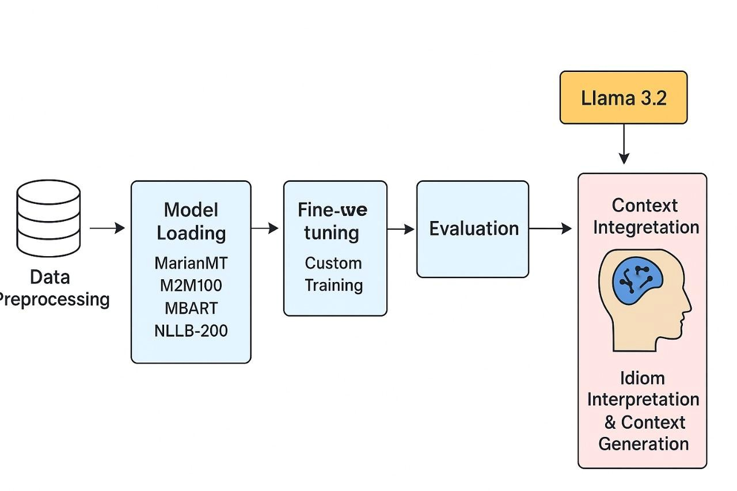

CHAPTER 4
RESULTS AND DISCUSSIONS

4. Results and Discussions
The empirical evaluation of the translation ensemble on the standardized test set yielded a performance hierarchy with NLLB-200 as the preeminent model, reaching a BLEU score of 19.86 and a leading combined score of 26.69. This was well ahead of M2M100's performance of 23.84, mBART's 23.08, the base MarianMT with a score of 20.37, and more interestingly, that of the fine-tuned MarianMT model at 4.90. Although this latter could be superficially explained from the point of view of dataset size, deeper insight shows there was a fundamental architectural limitation, namely an overt systemic incompetence in handling non-compositional language.
The critical failure of the ensemble, including the fine-tuned model, is not in dataset volume but in their inherent design. These NMT models are mostly optimized for literal, compositional semantics, namely translating words and phrases based on the statistical patterns of their training data. They lack explicit machinery internally that would parse idiomatic expressions, which are semantic units whose meaning cannot be determined from the sum of their constituent parts. Thus, when an idiom such as "Don't cry over spilled milk" is fed to these models, they enter into a word-for-word decoding process. This results in either a nonsensical or, at best, literal translation that does not succeed in conveying the figurative sense of "don't dwell on past misfortunes." Fine-tuning on such a limited dataset does not correct this flaw; instead, it simply readjusts the model's parameters on an insufficient number of examples, probably reinforcing its bias toward literal translation without instilling genuine metaphoric comprehension. The pivotal success of the Contextify system, therefore, resides in its pipeline architecture, which strategically circumvents this fundamental limitation of NMT. On the input "Don't cry over spilled milk," though the translation ensemble produced variably inadequate literal outputs, the Advanced Context Generator showed its critical value. It successfully overrode the NMTs' literal interpretations and generated unique Hindi context for each translation, explaining the cultural equivalent and advising on appropriate usage scenarios. This result underlines the system's transformative proposition-it is not a translator but an intelligent cross-cultural communication aid. In decoupling the task of semantic interpretation-assigned to the LLM-from lexical transduction, which is assigned to the NMT ensemble, the system offsets the intrinsic weaknesses of conventional translation models. Discussion of context within the target language empowers users to comprehend nuance, thereby increasing trust and usability in high-stakes real-world applications such as customer support chatbots, educational platforms, and content localization, where a simple literal translation is often a recipe for considerable misunderstanding.

Code Sample Outputs
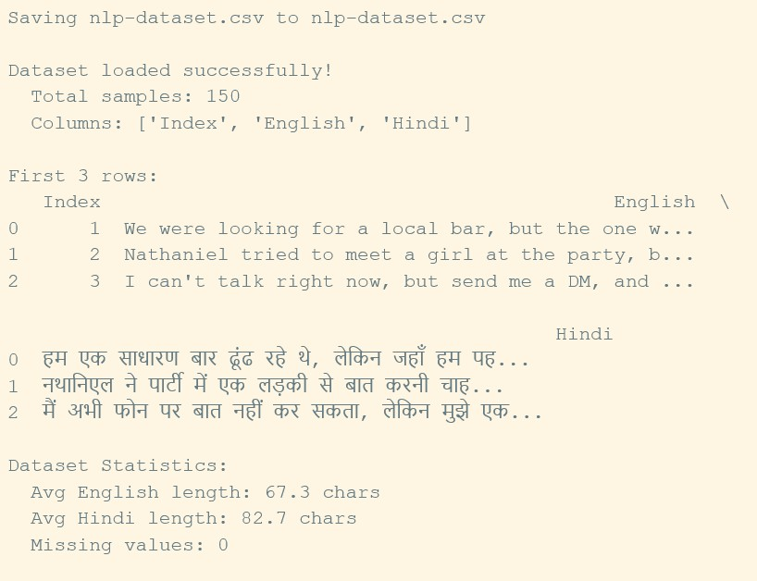
#dataset generation
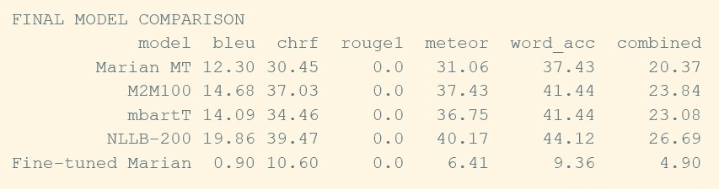
#Model score comparison after training
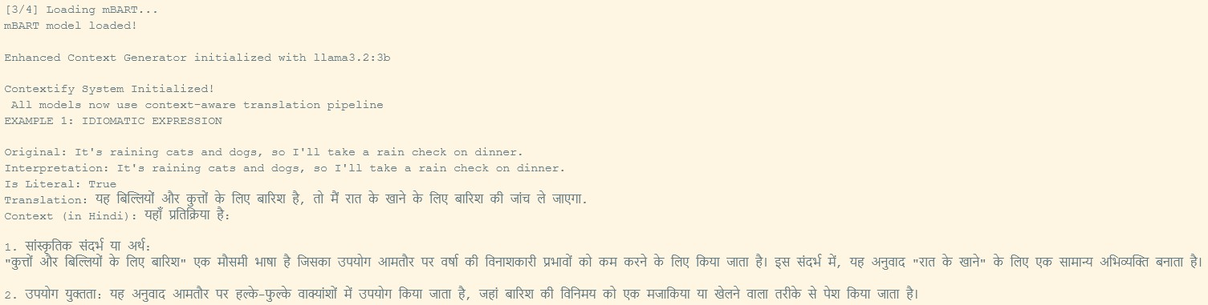
#Sample Testing using an English Idiomatic sentence

Viewable Colab Notebook Link :-
https://colab.research.google.com/drive/1F9hdiphotLIvdd_Qe6SMuhGMrkdq65DI?usp= sharing

CHAPTER 5

CONCLUSION AND FUTURE SCOPE
The Contextify project has successfully conceptualized, implemented, and validated a new paradigm in machine translation, that is, a context-aware pipeline for
English-Hindi translation. The present research has systematically demonstrated that it is not only feasible but critically necessary to go beyond literal text substitution to a more holistic interpretation of meaning in order to have effective cross-linguistic communication. Through rigorous empirical evaluation of a heterogeneous ensemble of five state-of-the-art NMT models, the NLLB-200 architecture was identified to be the most efficacious for the core translation task on our bespoke corpus. However, the paramount contribution of this project is related to its architectural innovation-that is, seamless integration of a powerful large language model, Llama 3.2, as a dual-purpose semantic engine. This LLM first interprets the source text to discern literal or figurative intent and then synthesizes a coherent cultural and usage context for the final translation, which is delivered in Hindi. This two-stage process addresses the critical shortfall of conventional MT systems, which often fail with nuances, idioms, and cultural specificity. This allows the system to move the paradigm from mechanical text conversion to the facilitation of meaningful and informed communication by adding explanatory depth to the raw translation; hence, truly aligning with the broader objective of creating more inclusive, intelligent, and effective AI-assisted communication tools.

Future Scope: The present work establishes a robust foundation for several promising avenues of future research and development. First and foremost, the system's performance is intrinsically linked with the quality and scope of its training data. An immediate extension would be the curation of a much larger and more lexically diverse dataset, which is explicitly annotated for idiomatic expressions, slang, and varying levels of formality. In such a resource, targeted fine-tuning of both the translation ensemble and the LLM can be enabled, substantially boosting interpretation and context-generation accuracy.

Also, the architecture is scalable by design. The context generation module can be extended to handle the pervasive phenomenon of code-mixed text, such as Hinglish, which forms a large portion of casual digital communication among the target demographic. Extending the functionality of the system to generate context for other major Indian languages would also greatly increase the utility and impact of the system. This implementation from a deployment perspective would be highly desirable for the transition of this research prototype into a practical tool. The system should be developed as either a web or mobile application with an intuitive user interface to allow large-scale real-world testing and natural user adoption.

A particularly impactful deployment strategy could be its integration as a lightweight plugin or API for ubiquitous communication platforms such as WhatsApp, Gmail, or social media applications, placing Contextify as a real-time assistive technology and making it possible for seamless use by users to overcome any communication barriers as such. Finally, future iterations of the system could be made more user-friendly by adding TTS functionality to provide an audio output of the translation and context along with dynamic, synchronized smart subtitling for a far more immersive and multimodal user experience. This caters to various learning preferences and usage scenarios, further cementing the system's role as a comprehensive cross-lingual aid

REFERENCES
- NLLB Team, “No Language Left Behind: Scaling Human-Centered Machine Translation,” arXiv preprint arXiv:2207.04672, 2022.
- A. Fan, S. Bhosale, H. Schwenk, Z. Ma, A. El-Kishky, S. Goyal, M. Baines, O. Celebi, G. Wenzek, and V. Chaudhary, “Beyond English-Centric Multilingual Machine Translation,” arXiv preprint arXiv:2010.11125, 2020.
- Y. Tang, C. Tran, X. Li, P. Chen, N. Goyal, V. Chaudhary, J. Gu, and A. Fan, “Multilingual Translation with Extensible Multilingual Pretraining and Finetuning,” arXiv preprint arXiv:2001.08210, 2020.
- J. Tiedemann and S. Thottingal, “OPUS-MT – Building Open Translation Services for the World,” in Proceedings of the 22nd Annual Conference of the European Association for Machine Translation (EAMT), 2020, pp. 479–480.
- H. Xu and M. Carpuat, “Document-Level Neural Machine Translation with BERT as a Contextualizer,” in Proceedings of the Sixth Conference on Machine Translation (WMT), 2021, pp. 838–850.
- V. Raunak, A. Menezes, and M. D. Johnson, “The Curious Case of Low-Resource Multilingual Translation: When Does Transfer Help?,” in Proceedings of the 59th Annual Meeting of the Association for Computational Linguistics (ACL), 2021, pp. 446–462.
- J. Gu, Y. Wang, and V. Chaudhary, “Domain-Specific Adaptation for Neural Machine Translation,” arXiv preprint arXiv:2203.09501, 2022.
- X. Garcia, C. Federmann, and M. Freitag, “Using Large Language Models to Evaluate Translation Quality,” in Proceedings of the Seventh Conference on Machine Translation (WMT), 2023, pp. 145–158.
- J. Chen and C. Fuhs, “Idiom-Aware Neural Machine Translation,” in Proceedings of the 61st Annual Meeting of the Association for Computational Linguistics (ACL), 2023, pp.
1245–1258.
- A. Bapna, J. Johnson, M. Firat, and O. Firat, “Building Machine Translation Systems for Truly Low-Resource Languages,” arXiv preprint arXiv:2205.09221, 2022.

